Uncovering Flight Delay Patterns
A Data-Driven Study of Aviation Operations

24ADI204 - DATA SCIENCE AND VISUALISATION
Submitted by

KARTHICK.N - 24BAD055
MANOJ. M - 24BAD067
NEHA.N. K - 24BAD078
PRANESH.M - 24BAD089
in partial fulfilment for the award of the degree of

BACHELOR OF TECHNOLOGY
IN

ARTIFICIAL INTELLIGENCE AND DATA SCIENCE


KUMARAGURU COLLEGE OF TECHNOLOGY
(An Autonomous Institution affiliated to Anna University, Chennai)

Post Box No: 2034, Coimbatore - 641049

APRIL 2026

BONAFIDE CERTIFICATE

Certified that this project report “Uncovering Flight Delay Patterns: A Data-Driven Study of Aviation Operations” is the Bonafide work of “KARTHICK N – 24BAD055, MANOJ M -24BAD067, NEHA N K - 24BAD078, PRANESH M – 24BAD089” who carried out the project work under my supervision.

SIGNATURE SIGNATURE

Dr. Sudharson D
HEAD OF THE DEPARTMENT
Department of Artificial Intelligence and Data Science,
Kumaraguru College of Technology, Coimbatore – 641049.
Ms. Rupashini P R
SUPERVISOR
Department of Artificial Intelligence and Data Science,
Kumaraguru College of Technology, Coimbatore – 641049.

The candidates with college register number 24BAD055, 24BAD067, 24BAD078, 24BAD089 were examined in the Project Viva-Voce examination held on
……………...

Internal Examiner Extenal Examiner


DECLARATION
I affirm that the project work titled “Uncovering Flight Delay Patterns: A Data-Driven Study of Aviation Operations” being submitted in partial fulfillment for the award of B. TECH Artificial Intelligence and Data Science is the original work carried out by us. It has not formed the part of any other project work
submitted for the award of any degree or diploma, either in this or any other University.

KARTHICK N – 24BAD055


MANOJ M - 24BAD067

NEHA N K - 24BAD078


PRANESH M – 24BAD089




I certify that the declaration made above by the candidates is true.
Ms. Rupashini P R

Assistant Professor,



Department of Artificial Intelligence and Data Science, Kumaraguru College of Technology,
Coimbatore – 641049.

Executive Summary

Problem Statement

The United States aviation network loses millions of operational minutes every year to flight delays, creating substantial financial and logistical disruptions for airlines, passengers, and airport authorities. Understanding whether delays originate from systemic carrier inefficiencies, unpredictable weather events, national airspace system (NAS) congestion, or cascading domino effects—where a late departure propagates into a late arrival—is a critical challenge. This project addresses the need to decode 1.7 million raw, heavily right-skewed flight operational records into meaningful visual narratives that identify root causes.
Dataset Used

The analysis is based on the 2024 US Domestic Flights dataset sourced from the Bureau of Transportation Statistics (BTS) / Department of Transportation, made accessible via Kaggle. The dataset encompasses 1,669,746 flight records with 26 original features, later expanded to 32 engineered features through transformation and feature creation. It covers the Top 10 highest-volume domestic airlines and major US airport hubs.

Key Findings
Finding | Detail
Positive Distribution | Distribution is positively skewed; most delays are small  with few extreme values.
Domino Effect | Departure and arrival delays share a 0.97 correlation: pilots frequently  recover  time mid-flight.
Independent Causes | Weather, carrier, NAS, and security delays act largely independent with  weak correlations.
Seasonal Vulnerability | Winter season shows highest delay probability (>15 min); “Late Aircraft” is  the dominant cause.
PCA Compression | Principal Component Analysis reduced dimensionality while  retaining most variance.
Dataset Readiness | All outliers capped (1440 min), skewness corrected via Cube Root,  and features scaled appropriately.

Final Insights – "So What?"

The analysis demonstrates that flight delays are not a monolithic problem. They are driven by multiple independent triggers—weather, carrier operations, airspace congestion, and cascading aircraft lateness—each requiring distinct intervention strategies. Airlines can improve on-time performance by targeting carrier-specific inefficiencies, while government agencies should focus on NAS bottlenecks at peak-volume hubs. The engineered dataset, now fully normalized and dimensionality-reduced, is ready for predictive machine learning models that could forecast delay probability for any given flight parameter combination.

Table of Contents

Executive Summary
List of Abbreviations
Chapter 1: Introduction 5
Chapter 2: Dataset Description 6
Chapter 3: Data Preprocessing and Cleaning 8
Chapter 4: Exploratory Data Analysis (EDA) 11
Chapter 5: Data Transformation and Feature Engineering 16
Chapter 6: Advanced Analysis – Correlation, Feature Selection & PCA 19
Chapter 7: Visualization and Dashboard 23
Chapter 8: Insights and Storytelling 26
Chapter 9: Conclusion 28
Chapter 10: References 30
Appendix 32

List of Abbreviations
BTS | Bureau of Transportation Statistics
NAS | National Airspace System
EDA | Exploratory Data Analysis
PCA | Principal Component Analysis
ML | Machine Learning
IQR | Interquartile Range
ARR_DELAY | Arrival Delay (minutes)
DEP_DELAY | Departure Delay (minutes)
CRS | Computer Reservation System (scheduled time)
DOT | Department of Transportation
CSV | Comma-Separated Values
API | Application Programming Interface
RAM | Random Access Memory
FAA | Federal Aviation Administration

Figure No. | Title | Description | Page No.
Figure 4.1 | Distribution of Departure Delay (Zoomed View) | Histogram showing power-law distribution of departure delays | 11
Figure 4.2 | Relationship between Departure and Arrival Delay | Scatter plot showing strong correlation (r = 0.97) | 12
Figure 4.3 | Impact of Weather Delay on Arrival Delay | Visualization of weather delay contribution | 13
Figure 4.4 | Delay Cause Distribution Across Seasons | Seasonal variation of delay causes | 14
Figure 4.5 | Correlation between Delay Variables | Heatmap of delay relationships | 15
Figure 5.1 | Skewness Reduction using Cube Root Transformation | Before vs after skewness correction | 16
Figure 5.2 | Distribution of Scaled Scheduled Times | MinMax scaling visualization | 17
Figure 6.1 | Full Feature Correlation Matrix | Heatmap of all numerical features | 19
Figure 6.2 | Cumulative Explained Variance of PCA Components | PCA variance curve | 21
Figure 6.3 | PCA Projection (PC1 vs PC2) | 2D PCA visualization | 20
Figure 6.4 | Feature Loadings for Principal Component 1 | Feature contribution to PC1 | 22
Figure 7.1 | Visualisation of the Dashboard | Airline Performance Across Seasons | 24
Figure 7.2 | Flight Delay Analysis Dashboard | Delay Composition & Scale | 25

Chapter 1: Introduction
Background of the Problem

The United States operates the world's largest and most complex aviation network. Annually, hundreds of millions of passengers rely on domestic flight services for both business and leisure travel. Despite technological advances in aviation management, flight delays remain a persistent and costly problem. According to the Bureau of Transportation Statistics, flight delays cost airlines, passengers, and the broader US economy billions of dollars each year in direct costs—including additional fuel consumption, crew overtime, and passenger compensation—as well as indirect costs through missed connections, lost business productivity, and diminished consumer confidence.
The complexity arises not from a single cause but from a web of interdependent operational factors. A delay at one major hub can cascade through the entire network, causing hundreds of secondary delays thousands of miles away. Weather events at origin airports, carrier scheduling inefficiencies, national airspace congestion, and late-arriving aircraft all interact in ways that are difficult to untangle using traditional reporting methods.

Importance of the Study

This study is significant because it moves beyond aggregate statistics and uses advanced data science techniques to decompose and visualize the true structural drivers of flight delays. By analyzing 1.7 million records with statistical rigor and visual storytelling, the project provides stakeholders—including airlines, airport authorities, and government regulators—with actionable intelligence that can guide operational improvements, infrastructure investments, and passenger communication strategies.

Objectives of the Project

- Primary Objective: To uncover the root operational and seasonal drivers of flight disruptions
using advanced visual storytelling and statistical analysis of 1.7 million US domestic flight records.
- Secondary Objective: To mathematically clean, normalize, and transform the heavily right-skewed dataset into a machine-learning-ready format through systematic preprocessing and feature engineering.
- Tertiary Objective: To apply dimensionality reduction (PCA) and develop an interactive visualization dashboard that communicates delay risk in an intuitive, decision-ready format.
Scope of the Project
Dimension | Scope Description
Data Footprint | 1,669,746 US domestic flight records from the full year 2024
Airlines Covered | Top 10 highest-volume domestic carriers by flight frequency
Airports Covered | Major US airport hubs included in the BTS dataset
Exclusions | Cancelled and diverted flights excluded; focus on continuous delay minutes
Geographic Boundary | US domestic routes only; no international flights
Time Boundary | Calendar year 2024 (full 12 months)
Output | Cleaned dataset, EDA visuals, PCA-reduced data, interactive dashboard

Chapter 2: Dataset Description

Source of Dataset
The dataset was sourced from the US Bureau of Transportation Statistics (BTS) / Department of Transportation (DOT), which is the official government body responsible for collecting and publishing US aviation performance data. The data was accessed and made publicly available via the Kaggle repository at:
- Dataset URL: https://www.kaggle.com/datasets/karthick564/flight-delay-analysis
- Cleaned Dataset: https://www.kaggle.com/datasets/karthick564/flight-delay-analaysis-cleaned
The BTS Airline On-Time Performance data is widely used in academic research, government policy analysis, and industry benchmarking due to its comprehensive coverage, structured format, and authoritative source.
Dataset Size and Structure
Total Records | 1,669,746 rows
Original Features | 26 columns
Engineered Features | 32 columns (after feature engineering)
File Format | CSV (Comma-Separated Values)
Data Type | Structured, tabular – numerical and categorical
Target Variable | ARR_DELAY (continuous) / IS_DELAYED (binary, >15 min threshold)
Time Coverage | Full calendar year 2024 (January–December)
Integer Columns | 11 columns
Float Columns | 11 columns
Object/Categorical | 4 columns

Description of Key Features
Feature Name | Type | Description
MONTH | Integer | Month of flight (1–12)
DAY_OF_MONTH | Integer | Day of month (1–31)
OP_UNIQUE_CARRIER | Categorical | Unique airline carrier code (e.g., AA, UA)

ORIGIN | Categorical | IATA code of departure airport
DEST | Categorical | IATA code of arrival airport
CRS_DEP_TIME | Integer | Scheduled departure time (HHMM format)
DEP_TIME | Float | Actual departure time
DEP_DELAY | Float | Departure delay in minutes (negative = early)
CRS_ARR_TIME | Integer | Scheduled arrival time
ARR_TIME | Float | Actual arrival time
ARR_DELAY | Float | TARGET: Arrival delay in minutes
CARRIER_DELAY | Float | Delay attributable to airline carrier operations
WEATHER_DELAY | Float | Delay attributable to weather conditions
NAS_DELAY | Float | Delay from National Airspace System (ATC/airport)
SECURITY_DELAY | Float | Delay from security screening
LATE_AIRCRAFT_DELAY | Float | Delay from late-arriving previous aircraft
CANCELLED | Binary | Flight cancellation indicator (0/1)
DIVERTED | Binary | Flight diversion indicator (0/1)
SEASON | Categorical | Engineered feature: Winter/Summer/Monsoon-Fall
Delay Category | Categorical | Engineered: On-Time/Slight/Moderate/Severe

Initial Data Issues

- Structural Missing Values (78%): Approximately 78% of missing values in delay columns (CARRIER_DELAY, WEATHER_DELAY, NAS_DELAY, etc.) were identified as structural missingness—representing on-time flights where no delay cause exists. These were NOT data entry errors but valid domain-specific absences.
- Cancelled / Diverted Records: Approximately 2–3% of records corresponded to cancelled or diverted flights with missing ARR_TIME values, making them irrelevant to delay prediction analysis.
- Extreme Outliers: DEP_DELAY values exceeded 3,000 minutes (over 50 hours) in some records, indicating severe storm events or system failures. Standard statistical methods could not handle these without transformation.
- Incorrect Data Types: The CRS_DEP_TIME and CRS_ARR_TIME columns were stored as integers (e.g., 1430 for 14:30), making temporal duration calculations impossible without format conversion.
- High Cardinality Categorical: The ORIGIN and DEST airport columns contained 300+ unique airport codes each. Naive One-Hot Encoding would generate 1,062+ columns, risking memory overflow on standard hardware.
- Right-Skewed Distributions: All delay variables exhibited extreme positive skewness (heavy right tail), making standard linear statistical models and visualisations misleading without transformation.

Chapter 3: Data Preprocessing and Cleaning

Data Loading and Initial Inspection

The raw dataset was loaded using the Pandas library into a Data Frame object. Initial inspection involved verifying the shape (rows × columns), examining column data types using df.dtypes, and computing summary statistics using df.describe(). The verified dataset dimensions were 1,669,746 rows × 26 columns, with a mix of integer, float, and object (categorical) types. No duplicate rows were detected.
Handling Missing Values

The missing value strategy was designed with domain expertise rather than generic statistical imputation. Three distinct categories of missing values were identified and handled separately:

Category | Columns Affected | Strategy Applied | Justification
Structural Missingness | CARRIER_DELAY, WEATHER_DELAY, NAS_DELAY, SECURITY_DELAY, LATE_AIRCRAFT_DELAY | Imputed with 0.0 | Missing values indicate no delay occurred (on-time flights), not actual absence
Unknown Arrival Data | ARR_TIME, ARR_DELAY (cancelled flights) | Records dropped | Cancelled flights are irrelevant for arrival delay analysis
Scheduled Times | CRS_DEP_TIME, CRS_ARR_TIME (small %) | Median imputation | Median is robust to outliers and preserves distribution

Data Type Correction and Time Feature Engineering

The CRS_DEP_TIME and CRS_ARR_TIME columns were originally stored as integers in HHMM format (e.g., 1430 representing 14:30). This format is mathematically incorrect for duration calculations because 1430 + 200 ≠ 1630 in time arithmetic. A custom conversion function was applied to transform these values into 'minutes past midnight' (0–1439), enabling accurate time-of-day analysis and scaling.

def convert_to_minutes(time_int): hours = time_int // 100 minutes = time_int % 100 return hours * 60 + minutes

df['CRS_DEP_TIME'] = df['CRS_DEP_TIME'].apply(convert_to_minutes)

Outlier Detection and Management

Flight delay data presents a unique outlier challenge: extreme delays (e.g., 52-hour delays during major weather events or aircraft groundings) are real events, not data entry errors. Standard outlier removal would delete genuine operational failures from the dataset. Two methods were applied:

- Boxplot / IQR Method: Used to visualise the extent of the right tail and identify specific percentile thresholds. The IQR analysis confirmed that delays beyond 1440 minutes (24 hours) were statistically extreme yet operationally plausible.
- Z-Score Analysis: Z-scores beyond +=3 were computed to quantify extreme observations. Values exceeding 3,000 minutes (Z > 10) were classified as severe weather or system-failure events.
- Winsorization (Capping at 1440 min): Rather than deleting these records, all delay values exceeding 1440 minutes were capped at 1440. This preserves the 'severe delay' signal while preventing extreme values from distorting statistical measures like mean and variance.

Key Insight: The decision to cap at 1440 minutes (24 hours) was deliberate: it retains 100% of
flight records while preventing a single 52-hour ground stop from inflating the mean
departure delay by several minutes.

As a final enhancement to Week 3 processing, a categorical classification column Delay Category was created from the ARR_DELAY variable to facilitate segmentation analysis and visualization:

Delay Category Feature Creation

Category Label | ARR_DELAY Range | Record Count | Percentage
On-Time / Early | ≤ 0 minutes | ~1,043,591 | 62.5%
Slight Delay | 1 – 30 minutes | ~384,040 | 23.0%
Moderate Delay | 31 – 120 minutes | ~185,342 | 11.1%
Severe Delay | > 120 minutes | ~56,773 | 3.4%

Data Quality Report Summary
Quality Metric | Before Cleaning | After Cleaning
Total Records | ~1,700,000+ | 1,669,746
Null Values in Delay Cols | ~78% (structural) | 0 (imputed/dropped)
Data Type Errors | Time as integer (HHMM) | Converted to minutes
Extreme Outliers (>3000 min) | Present (~0.01%) | Capped at 1440 min
Cancelled / Diverted | Included (~2-3%) | Removed from analysis
Duplicate Rows | None detected | None
Final Clean Status | - | 100% analysis-ready

Chapter 4: Exploratory Data Analysis (EDA)

Week 4 of the project was dedicated to translating the clean, verified dataset into actionable visual insights. EDA was structured across four analytical dimensions: univariate distribution analysis, bivariate relationship mapping, categorical performance comparison, and temporal/seasonal risk assessment.
Univariate Analysis – Distribution of Delays

Histograms of DEP_DELAY and ARR_DELAY were generated with a zoomed-in axis range of 0–300 minutes to accurately represent most observations. The full range (0–1440 min) was also plotted to visualize the tail behavior.
- Power-Law Distribution: Both delay variables follow a strict heavy-tailed power-law distribution, with most flights concentrated near zero delay and an exponentially decreasing frequency as delay magnitude increases.
- Operational Floor: The distribution has no significant left tail. Flights cannot depart or arrive substantially before schedule in normal operations, creating a hard lower boundary near zero.
- Peak Concentration: Over 800,000 flights (approximately 48%) recorded delays of less than 15 minutes, confirming that most of the network operates within acceptable on-time boundaries.
- Extreme Right Tail: The tail extends to 1440 minutes, representing network failures (major weather events, system-wide groundings) rather than typical operational delays.

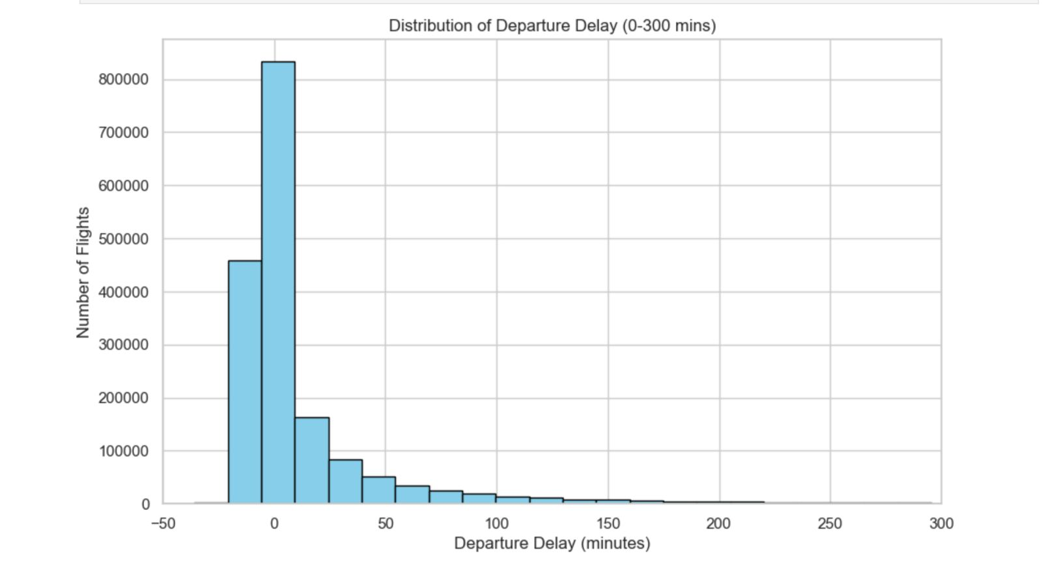
Figure 4.1: Distribution of Departure Delay (Zoomed View)

Key Insight: The Power-Law distribution of flight delays has critical implications: mean delay is a misleading metric. Median delay (approximately 0 minutes for on-time flights) and 95th percentile delay (approximately 120+ minutes) are far more informative measures for operational planning.

A bivariate density scatter plot was engineered using alpha-blending (alpha=0.05) to handle the 1.7 million data points without overplotting. A reference diagonal line (slope=1, intercept=0) was overlaid to indicate the 1:1 ratio between departure and arrival delay.
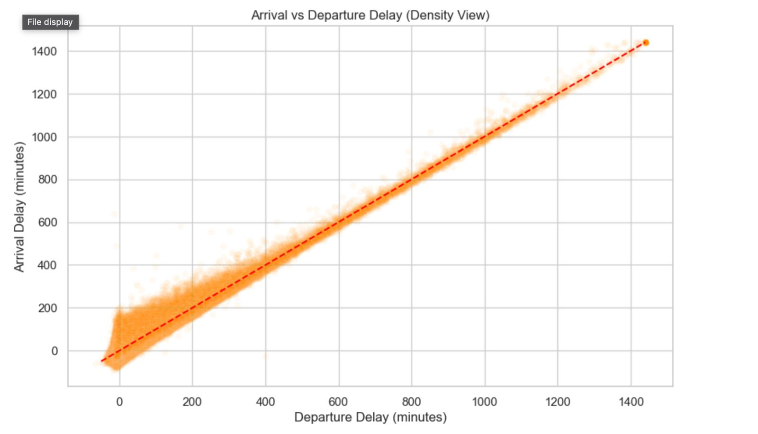
Figure 4.2: Relationship between Departure and Arrival Delay

Bivariate Analysis – The Departure-Arrival Delay Relationship

Correlation Coefficient | r = 0.97 (near-perfect positive linear correlation)
Below-Diagonal Cluster | Pilots "making up time" mid-air; ARR_DELAY < DEP_DELAY
On-Diagonal Cluster | Delay fully transferred from departure to arrival
Above-Diagonal Points | Additional delays acquired en-route or at destination
Visualization Challenge | Overplotting solved via alpha=0.05 transparency layering

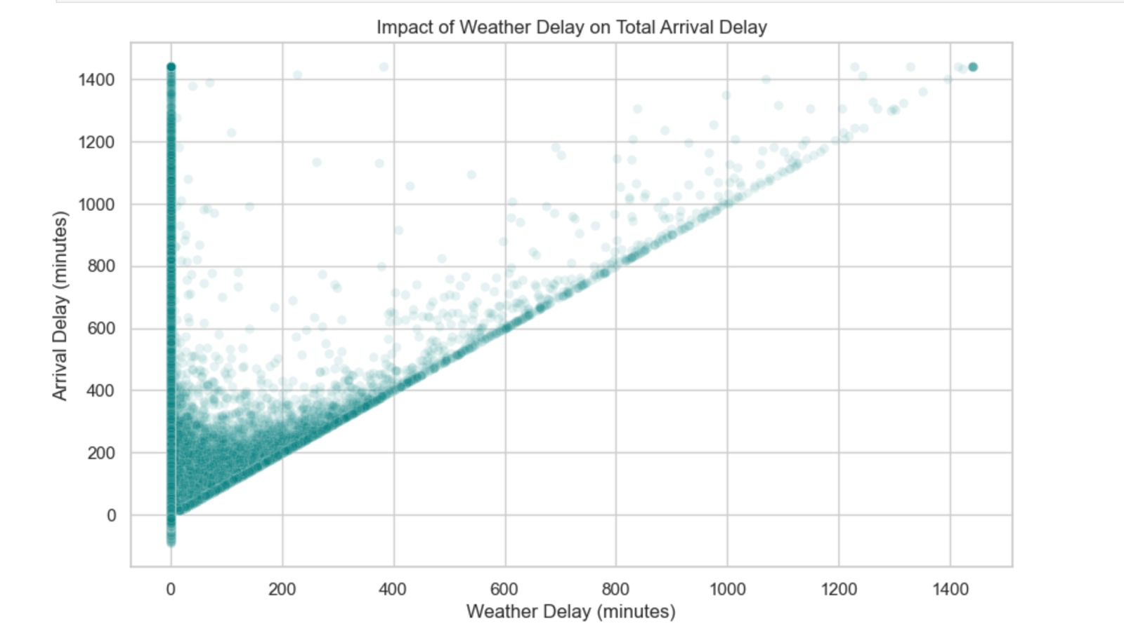
Figure 4.3: Impact of Weather Delay on Arrival Delay

Categorical Analysis – Top 10 Airlines
Boxplots were constructed for the Top 10 highest-volume domestic airlines by flight frequency. Each boxplot displays the interquartile range (IQR), median, and whiskers for ARR_DELAY values, filtered to the
0–300-minute range for visual clarity.
- Operational Variance: Airlines with compact IQR boxes demonstrate tighter operational control and scheduling discipline compared to airlines with wide boxes indicating high variance.
- Median Delay Position: Most top-volume carriers show median ARR_DELAY at or near zero, confirming that most flights are on-time even for high-frequency airlines.
- Outlier Density: High-volume carriers naturally show more outlier points due to larger sample sizes, not necessarily worse performance; normalization by flight count was considered.

Seasonal Risk Factor Analysis

A new categorical feature SEASON was engineered by mapping calendar months to operational seasons:
Winter (Dec–Feb), Summer (Jun–Aug), and Monsoon/Fall (Mar–May, Sep–Nov). Rather than analyzing average delay minutes, a probability-based metric was computed: the percentage of flights exceeding the 15-minute industry-standard delay threshold.

Season | Delay Probability (>15 min) | Primary Cause | Risk Level
Winter (Dec–Feb) | Highest (~33–35%) | Weather + NAS Congestion | - HIGH
Summer (Jun–Aug) | Moderate (~28–30%) | Carrier + Late Aircraft | - MEDIUM
Monsoon/Fall (Mar–May,  Sep–Nov) | Llowest (~24–26%) | Late Aircraft (Domino) | - LOW-MED

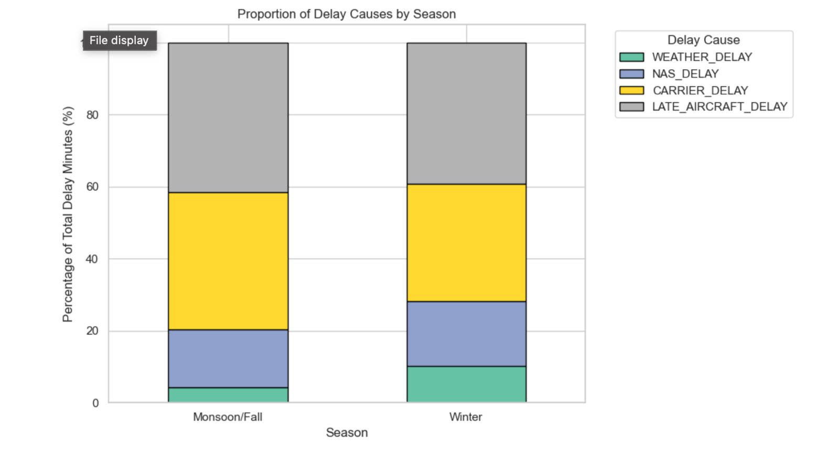
Figure 4.4: Delay Cause Distribution Across Seasons

Correlation Analysis – Delay Causes

A targeted correlation heatmap was constructed for the five delay cause variables: CARRIER_DELAY, WEATHER_DELAY, NAS_DELAY, SECURITY_DELAY, and LATE_AIRCRAFT_DELAY, along with the
primary delay metrics DEP_DELAY and ARR_DELAY.

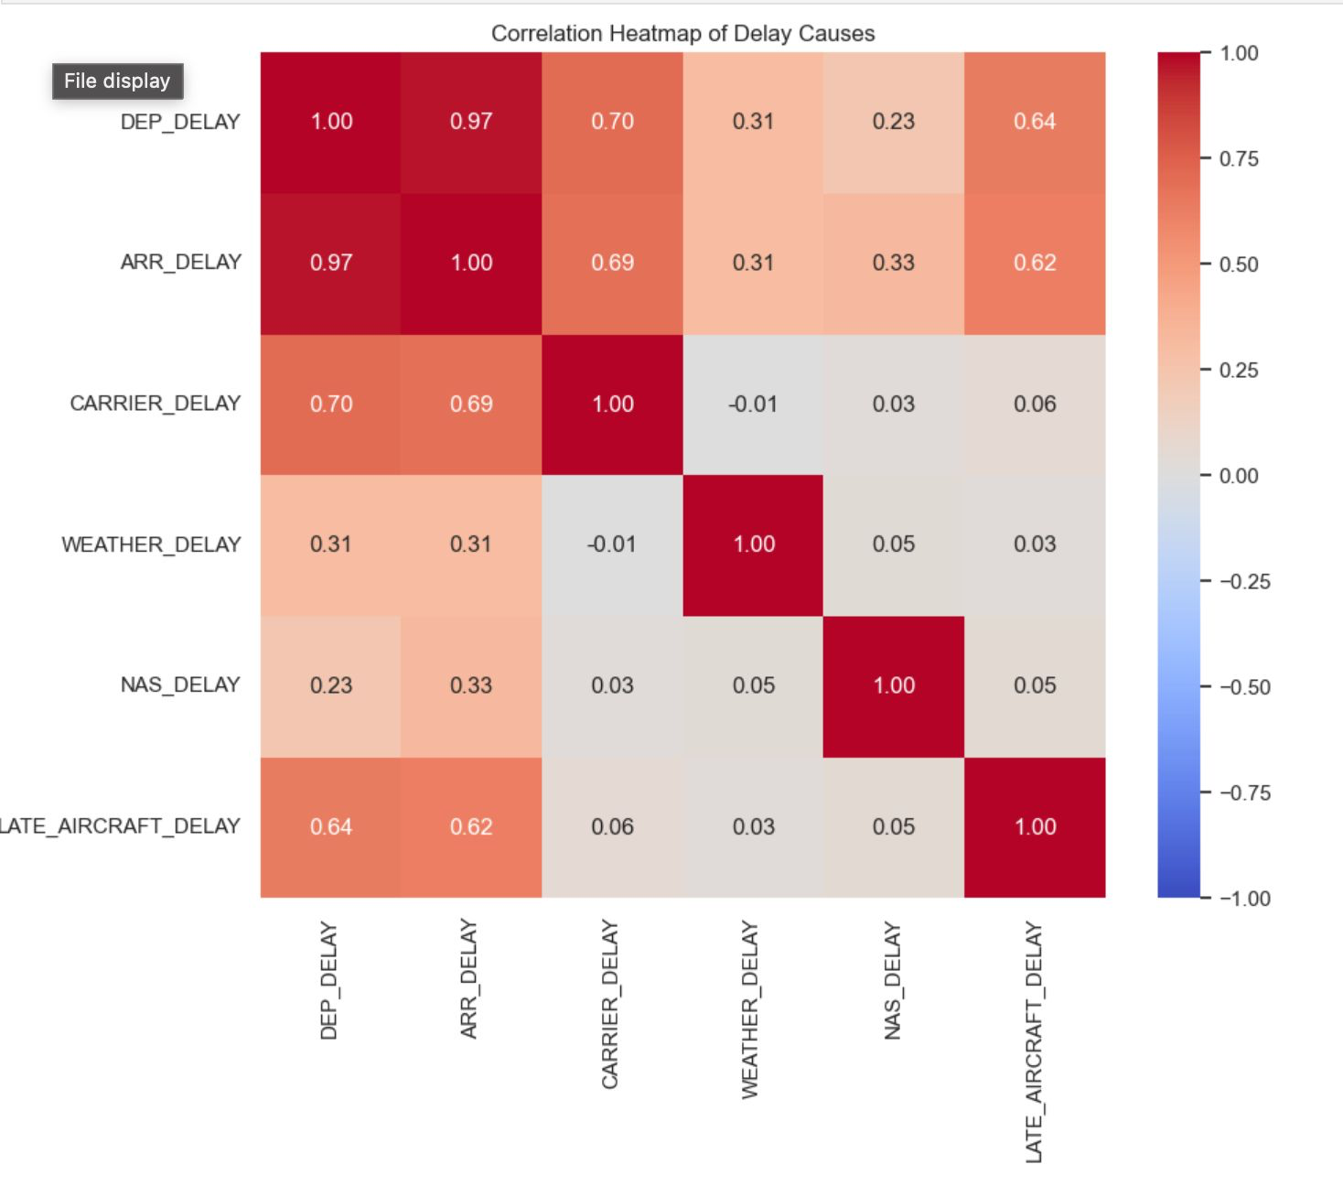
Figure 4.5: Correlation between Delay Variables

Variable Pair | Correlation (r) | Interpretation
DEP_DELAY < - >ARR_DELAY | 0.97 | Near perfect: Late departure = Late arrival
CARRIER_DELAY< - >WEATHER_DELAY | ~0.05 | Independent: Different causal mechanisms
WEATHER_DELAY < - >NAS_DELAY | ~0.08 | Weakly correlated: Some weather causes ATC issues
LATE_AIRCRAFT_DELAY< - >DEP_DELAY | ~0.65 | Moderate: Domino effect contribution
SECURITY_DELAY < - > All Others | ~0.02 | Essentially independent

Chapter 5: Data Transformation and Feature Engineering

Week 6 of the project focused on transforming the analytically clean dataset into a statistically balanced, mathematically normalized format suitable for machine learning algorithms. This involved four core operations: skewness correction, feature scaling, categorical encoding, and dataset export.

Handling Skewness – Cube Root Transformation
The DEP_DELAY variable exhibited extreme positive skewness (skewness coefficient > 5.0), characteristic of a heavy-tailed power-law distribution. Three transformation methods were evaluated:

Transformation | Handles Negatives | Handles Zeros | Result on DEP_DELAY
Log Transform | No (fails on neg.) | No (log(0) = undefined) | Not applicable
Square Root | No | Yes (sqrt 0=0) | Partial improvement
Cube Root | Yes ((-x) = -x) | Yes (0=0) | Best symmetry achieved
Yeo-Johnson | Yes | Yes | Applied to supplementary vars

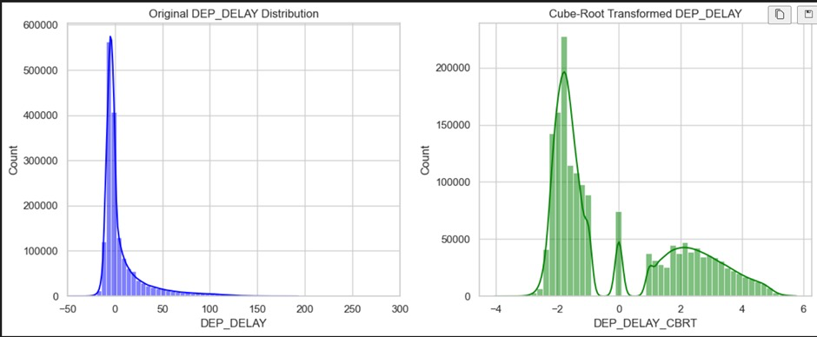
Figure 5.1: Skewness Reduction using Cube Root Transformation
Why Cube Root was selected: Flight delay values include negative numbers (early arrivals) and zero (on-time flights). Unlike logarithmic or square root transformations—which are undefined for non-positive values—the cube root is a bijective function that handles the full range of real numbers. Post-transformation, the distribution became significantly more symmetric, enabling better performance in downstream regression models.

Feature Scaling – MinMax Normalization

The scheduled time features CRS_DEP_TIME and CRS_ARR_TIME (converted to minutes past midnight) ranged from 0 to 1439. Without scaling, these large numerical values would dominate distance-based algorithms and disproportionately influence gradient calculations. MinMax scaling was applied to compress values to [0, 1]:
X_scaled = (X - X_min) / (X_max - X_min)
Where X_min = 0 (midnight) and X_max = 1439 (23:59)
StandardScaler (Z-score): Applied to the 15 selected features in Week 7 prior to PCA, ensuring zero mean and unit variance. This is mandatory for PCA to prevent high-magnitude features from dominating the principal components.
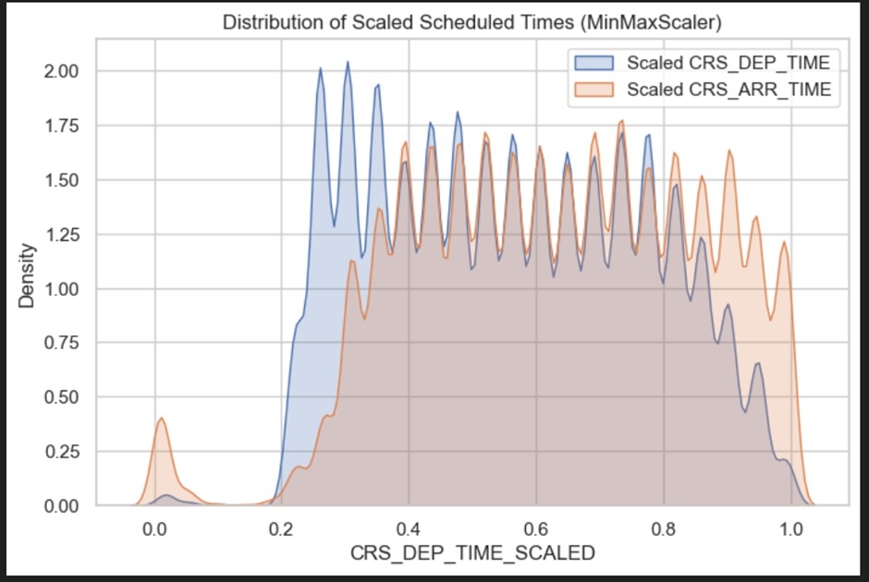
Figure 5.2: Distribution of Scaled Scheduled Times

Encoding Categorical Variables

Three categorical features with high cardinality required encoding before they could be used in machine learning models:

Feature | Unique Values | Encoding Method | Justification
OP_UNIQUE_CARRIER | 10–15 carriers | Label Encoding | Low cardinality; ordinal mapping is sufficient and memory efficient
ORIGIN (Airport) | 300+ codes | Label Encoding | One-Hot encoding would create 300+ columns, increasing dimensionality
DEST (Airport) | 300+ codes | Label Encoding | Same as ORIGIN; avoids high memory usage and dimensional explosion
SEASON | 3 categories | Label Encoding | Natural ordinal relationship exists (e.g., Winter < Summer < Monsoon)
DelayCategory | 4 categories | Label Encoding | Ordinal severity exists (On-Time < Slight < Moderate < Severe)

Before vs. After Comparison
Feature/Metric | Before Transformation | After Transformation
DEP_DELAY skewness | >5.0 (extreme right skew) | ~0.8 (near symmetric after cube root)
CRS_DEP_TIME range | 0 – 1439 (minutes) | 0.0 – 1.0 (MinMax scaled)
Airport codes (ORIGIN) | String e.g., "ATL", "LAX" | Integer 0–300 (Label Encoded)
Airline code | String e.g., "AA", "UA" | Integer 0–14 (Label Encoded)
Dataset columns | 26 original features | 32 features (6 engineered)
ML readiness | Not ready (mixed types, skewed) | 100% ready (numeric, normalized)

Chapter 6: Advanced Analysis
Correlation Analysis
A comprehensive correlation matrix was computed for all 22 numerical features in the engineered dataset. The resulting Seaborn heatmap (annotated with correlation coefficients) revealed three highly correlated feature pairs with |r| > 0.9:

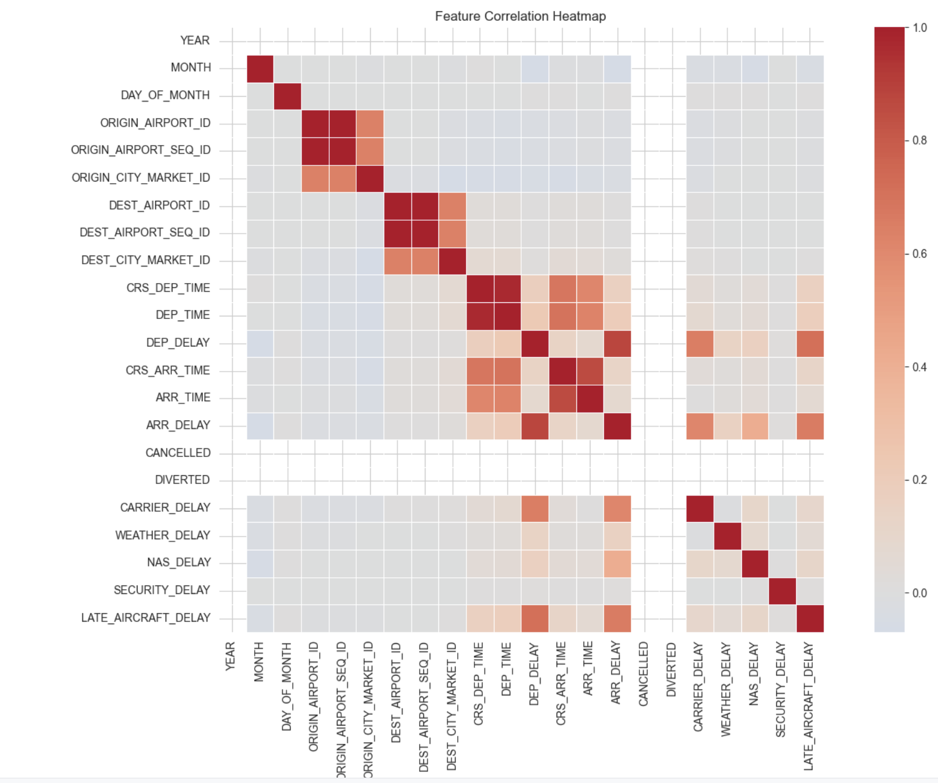

Figure 6.1: Full Feature Correlation Matrix

Feature Pair | Correlation (|r|) | Action Taken
ORIGIN_AIRPORT_SEQ_ID< ->ORIGIN_AIRPOR | T>_I0D.99 | SEQ_ID dropped (duplicate)
DEST_AIRPORT_SEQ_ID< - >DEST_AIRPORT_ID | > 0.99 | SEQ_ID dropped (duplicate)
DEP_TIME< - >CRS_DEP_TIME | > 0.95 | DEP_TIME dropped (redundant with schedule)

Feature Selection Pipeline
A systematic three-stage feature selection pipeline was applied to reduce the 22 numerical features to the 15 most informative variables for PCA:
- Stage 1 – Variance Threshold Filtering: Applied Variance Threshold (threshold=0.01) to remove near-constant features that provide no discriminative power. Result: 4 columns removed → 18 features remaining.
- Stage 2 – Correlation-Based Removal: Dropped the 3 redundant features identified in the heatmap. Result: 15 features remaining.
- Stage 3 – SelectKBest (ANOVA F-test): Attempted supervised selection using CANCELLED as target variable. Final 15 features used directly for PCA as no additional significant reduction was warranted.

Final 15 Selected Features: MONTH, DAY_OF_MONTH, ORIGIN_AIRPORT_ID, ORIGIN_CITY_MARKET_ID, DEST_AIRPORT_ID, DEST_CITY_MARKET_ID, CRS_DEP_TIME, DEP_DELAY, CRS_ARR_TIME, ARR_TIME, ARR_DELAY, CARRIER_DELAY, WEATHER_DELAY, NAS_DELAY, LATE_AIRCRAFT_DELAY

Principal Component Analysis (PCA)
PCA was applied to the StandardScaler-normalized 15-feature matrix (shape: 1,669,746 × 15) to decompose the feature space into uncorrelated principal components ordered by explained variance.

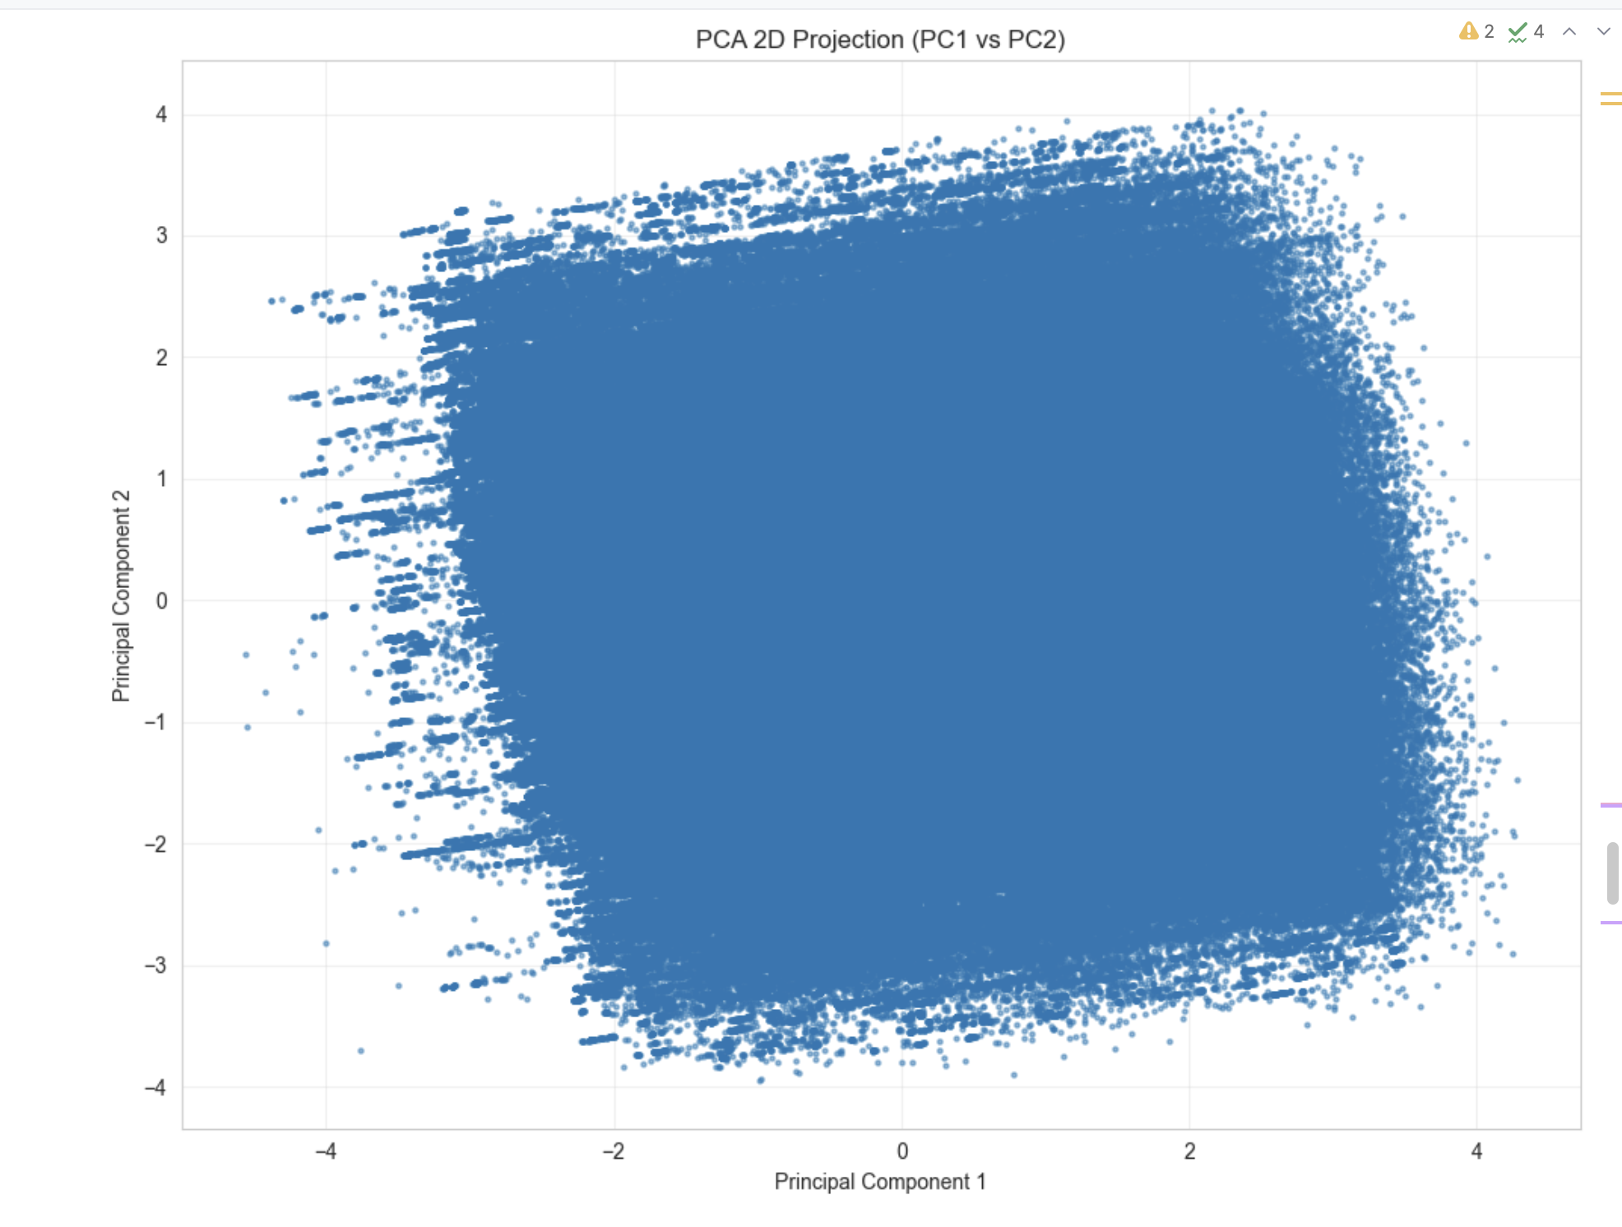

Figure 6.3: PCA Projection (PC1 vs PC2)

Principal Component | Individual Variance (%) | Cumulative Variance (%)
PC1 | 21.28% | 21.28%
PC2 | 15.13% | 36.41%
PC3 | 12.05% | 48.46%
PC4 | 9.87% | 58.33%
PC5 | 8.14% | 66.47%
PC6 | 6.92% | 73.39%
PC7 | 5.81% | 79.20%
PC8 | 6.12% | 85.32%
PC9 - 90% threshold | 5.11% | 90.43%
PC10 | 2.85% | 93.28%
PC11 - 95% threshold | 2.42% | 95.70%

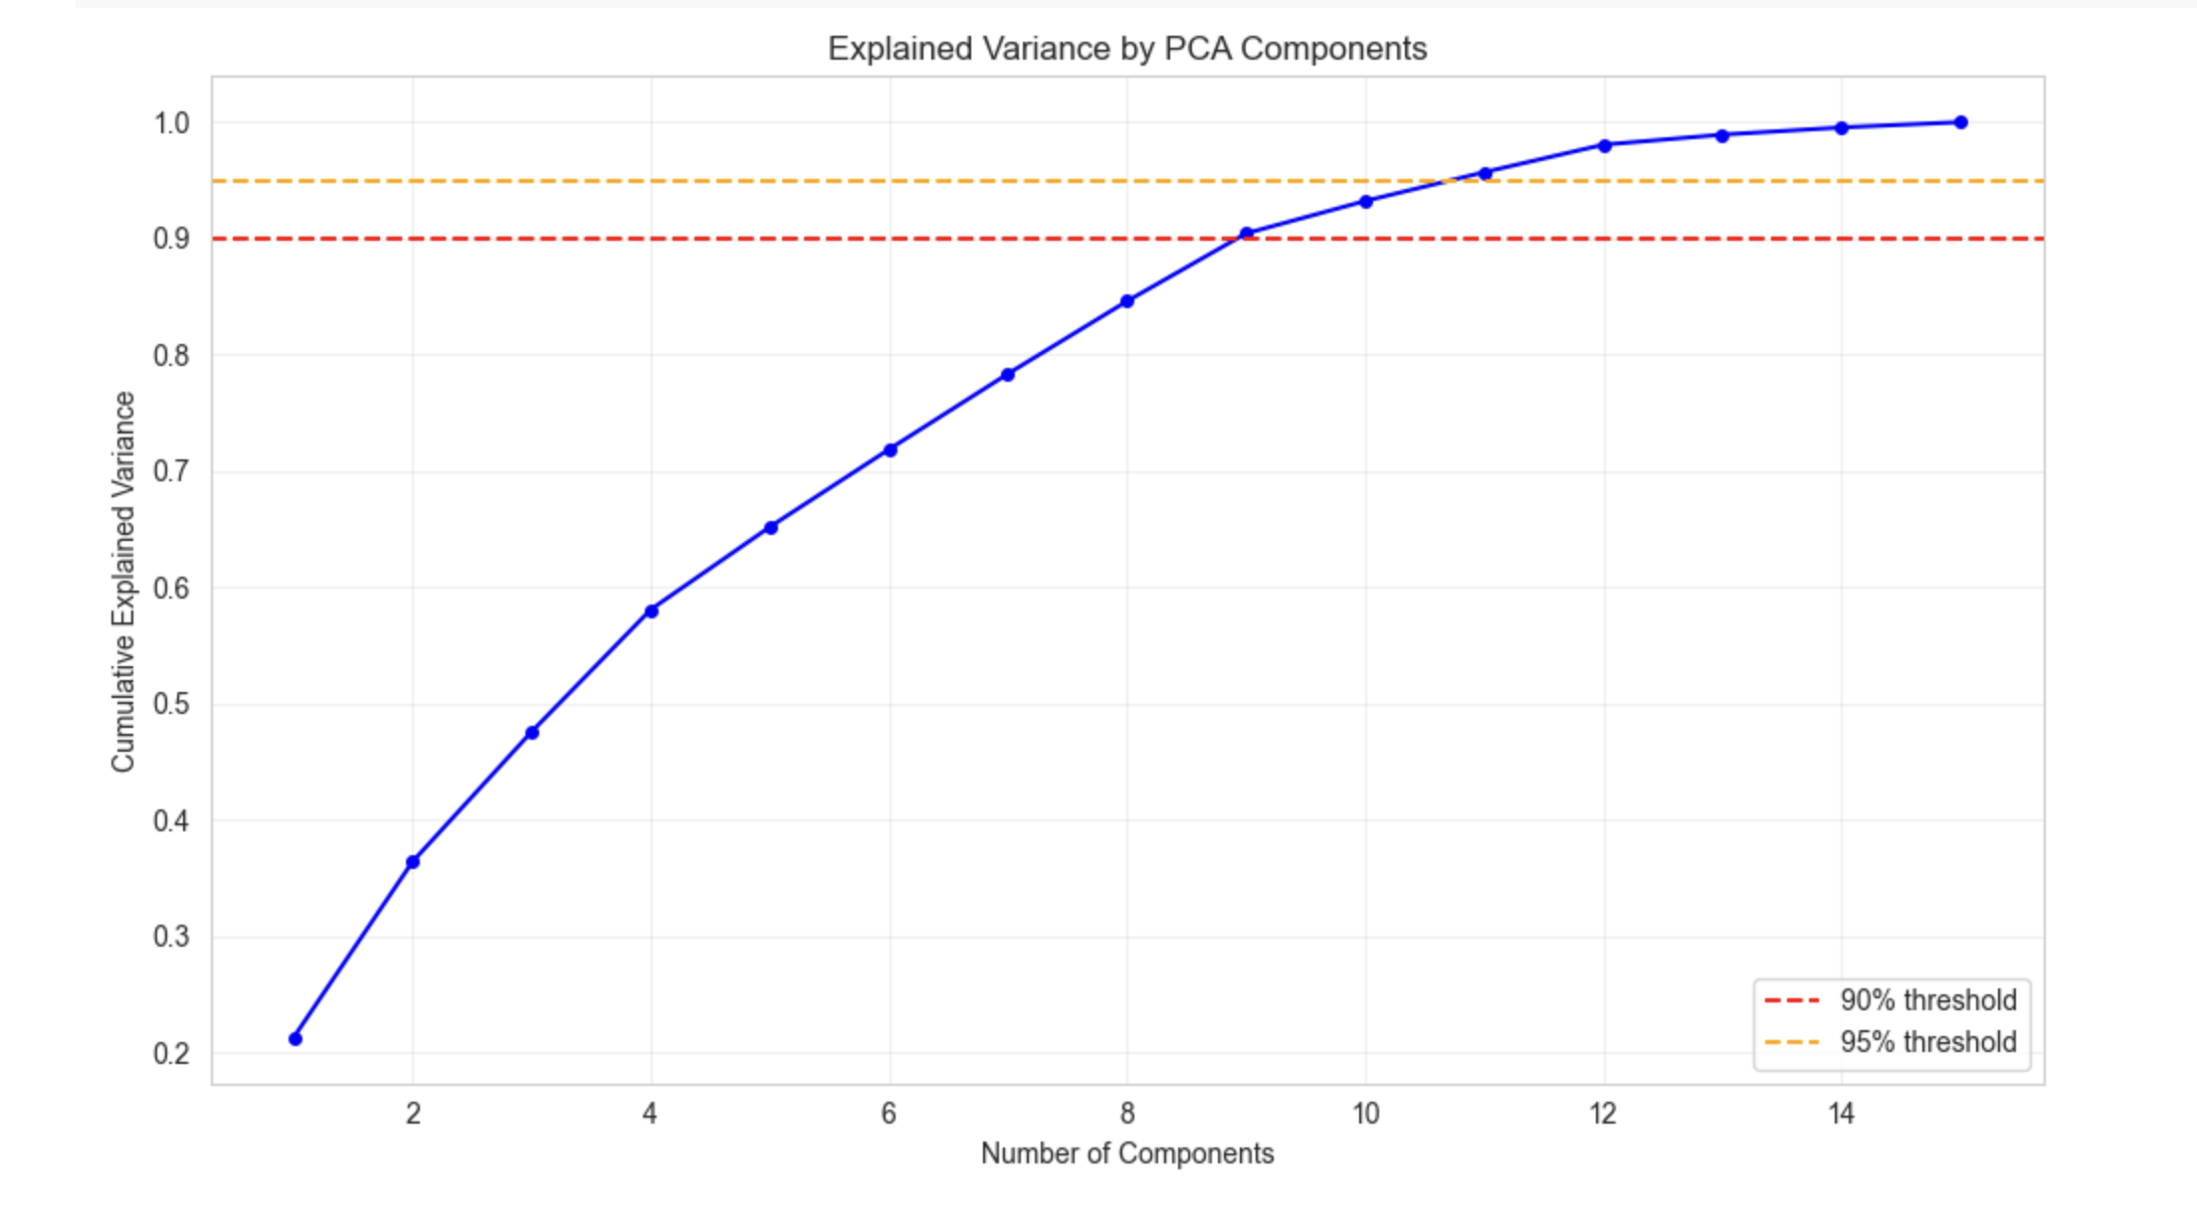
Figure 6.2 Cumulative Explained Variance of PCA Components

PCA Component Interpretation

PCA loading analysis identified which original features contribute most strongly to each principal component, enabling domain-level interpretation:
Principal component analysis (PCA) reveals several meaningful latent patterns in the dataset. The first principal component (PC1), explaining 21.28% of the variance, is dominated by ARR_DELAY, DEP_DELAY, and CARRIER_DELAY and represents a Delay Magnitude Axis, capturing the overall severity of flight delays across multiple dimensions. The second component (PC2), accounting for 15.13% of the variance, is influenced by ORIGIN_AIRPORT_ID, DEST_AIRPORT_ID, and ORIGIN, forming a Geographical Axis that reflects airport locations and route-based spatial patterns in flight operations. The third component (PC3), contributing 12.05% of the variance, is driven by WEATHER_DELAY and NAS_DELAY, representing an External Disruption Axis associated with environmental and air-traffic-control-related delays. The fourth component (PC4), explaining 9.87% of the variance, includes CRS_DEP_TIME, CRS_ARR_TIME, and MONTH, forming a Temporal Scheduling Axis that captures time-of-day and seasonal effects on flight scheduling. Overall, nine principal components were selected, retaining 90.43% of the total dataset variance while reducing dimensionality from 15 to 9 features—a 40% reduction. The transformed dataset was saved as reduced_features_week7.csv, with a final shape of
1,669,746 × 9.

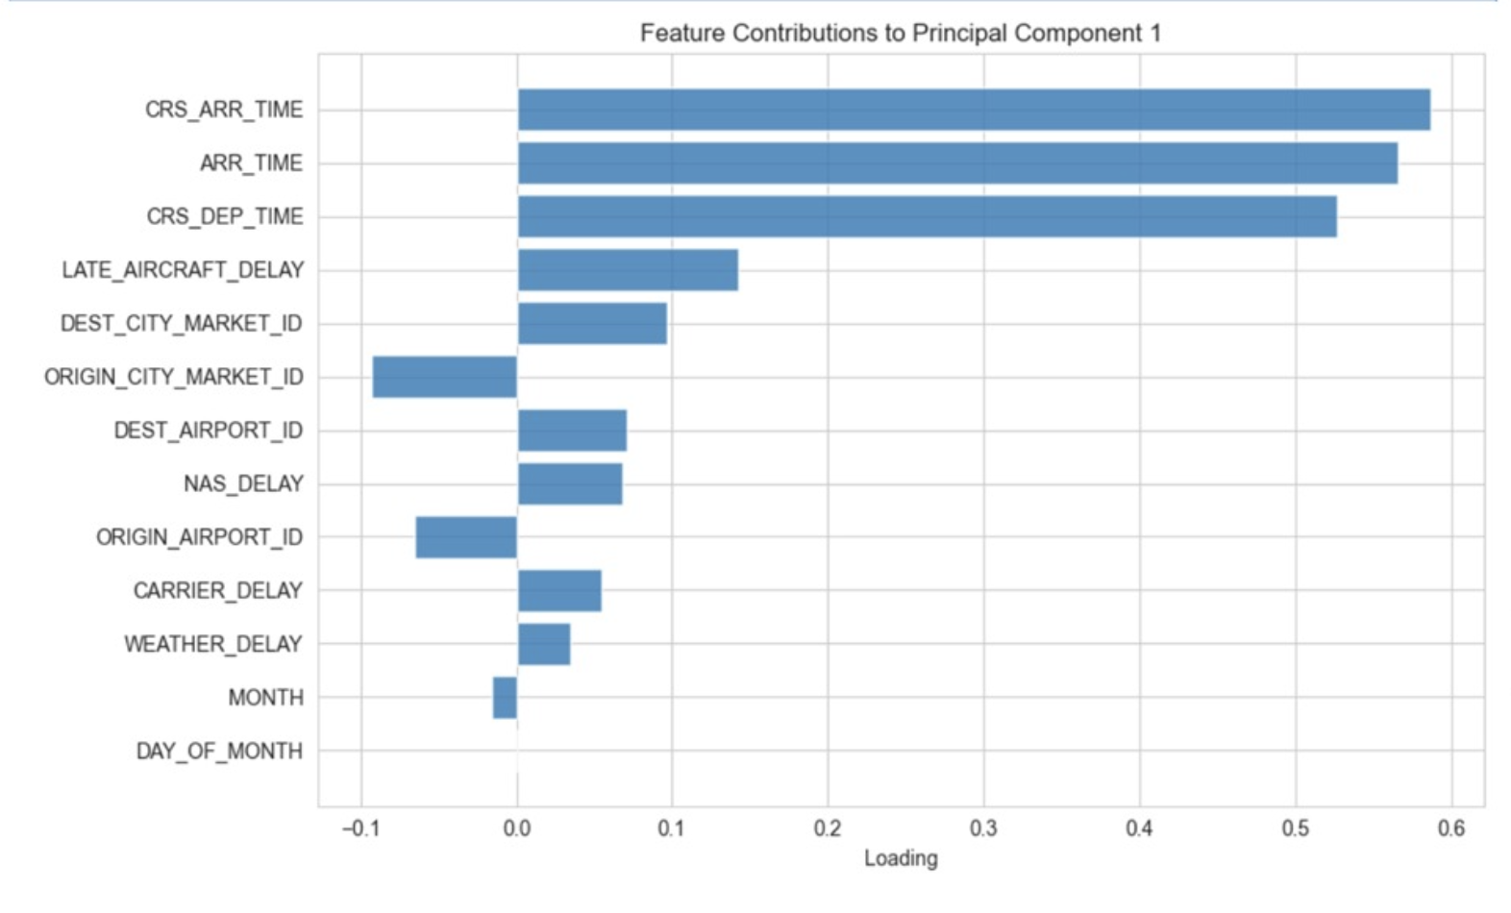
Figure 6.4: Feature Loadings for Principal Component 1

Chapter 7: Visualization and Dashboard

Tools and Libraries Used
Tool / Library | Version | Purpose
Python | 3.11+ | Core analysis language
Pandas | 2.x | Data manipulation and aggregation
NumPy | 1.x | Numerical operations and transformations
Matplotlib | 3.x | Base plotting and figure management
Seaborn | 0.13+ | Statistical visualizations (heatmaps, boxplots, distributions)
Scikit-learn | 1.x | PCA, scaling, encoding, feature selection
Streamlit | Latest | Interactive web dashboard framework
Plotly | Latest | Interactive charts within dashboard
Jupyter Notebook | 7.x | Development and documentation environment
GitHub | – | Version control and team collaboration
Kaggle | – | Dataset hosting and notebook environment

Visualization Catalogue (Minimum 5 Types)
# | Visualization Type | Variable(s) | Key Finding
1 | Histogram (Distribution) | DEP_DELAY, ARR_DELAY | Power-law distribution; 62.5% on-time
2 | Bivariate Scatter (Density) | DEP_DELAY vs ARR_DELAY | 0.97 correlation; time recovery below diagonal
3 | Box Plot (Categorical) | ARR_DELAY by Airline | Carrier-specific operational variance patterns
4 | Stacked Bar Chart | Delay causes by Season | Winter: highest weather/NAS contribution
5 | Correlation Heatmap | All delay variables | Independent causes: DEP↔ARR dominates

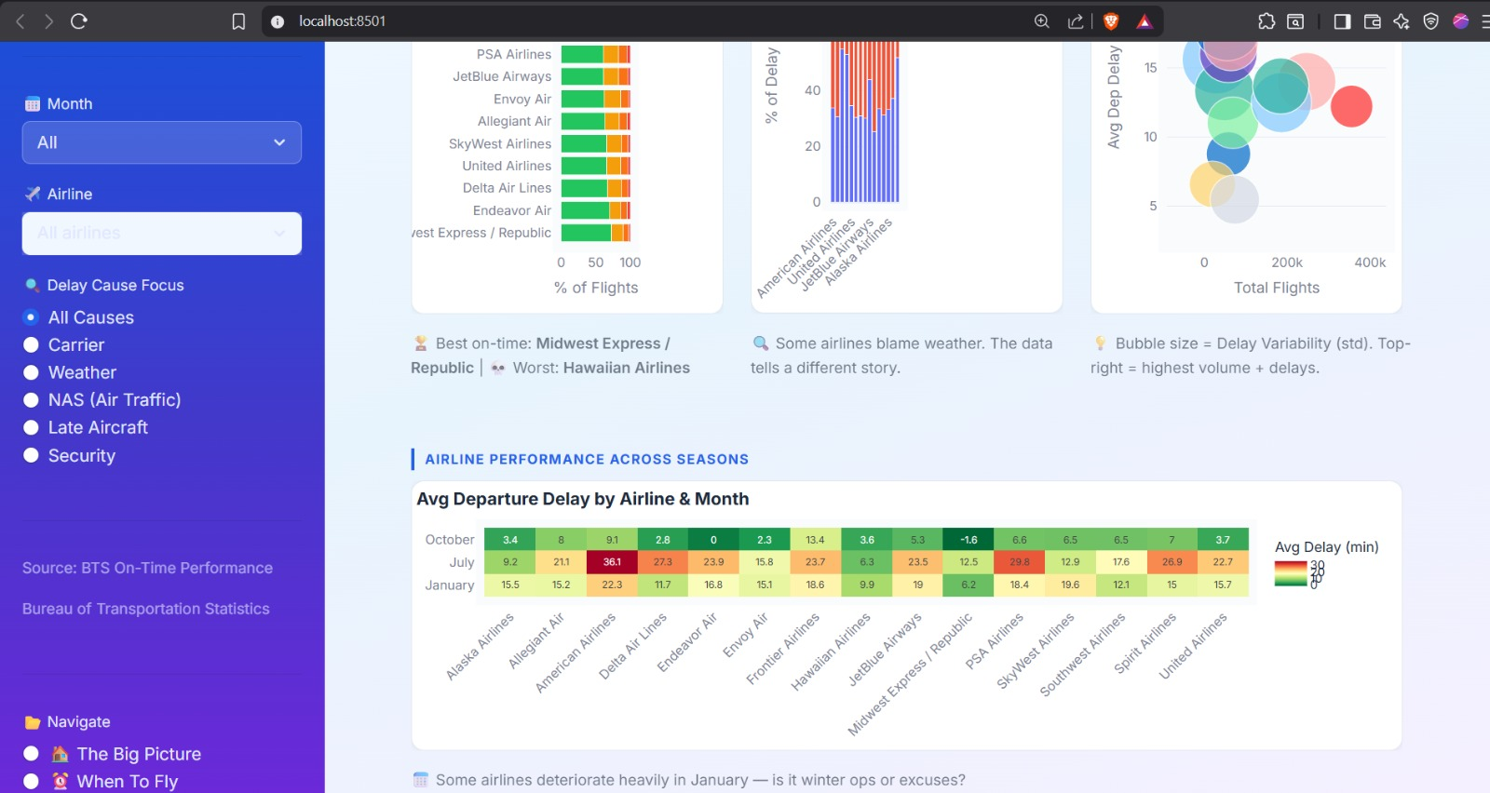

Figure 7.1: Airline Performance Across Seasons

Interactive Dashboard Description

The final project dashboard was built using Streamlit as the web framework and Plotly for interactive chart rendering. The dashboard enables stakeholders to explore delay patterns dynamically without requiring programming knowledge.
- Airline Filter Panel: Dropdown to select individual carriers or 'All Airlines' for comparative analysis
- Season / Month Selector: Toggle between seasonal and monthly granularity for temporal analysis
- Delay Type Breakdown: Pie and stacked bar charts showing the proportional contribution of each delay cause
- Route Risk Map: Plotly choropleth / scatter map visualizing delay hotspots by origin airport
- Distribution Explorer: Interactive histogram with adjustable bin size and zoom capability
- PCA Projection Panel: 2D scatter of PC1 vs PC2 with color encoding by season or delay category
- Statistical Summary Cards: KPI cards displaying total flights, mean delay, on-time rate, severe delay count

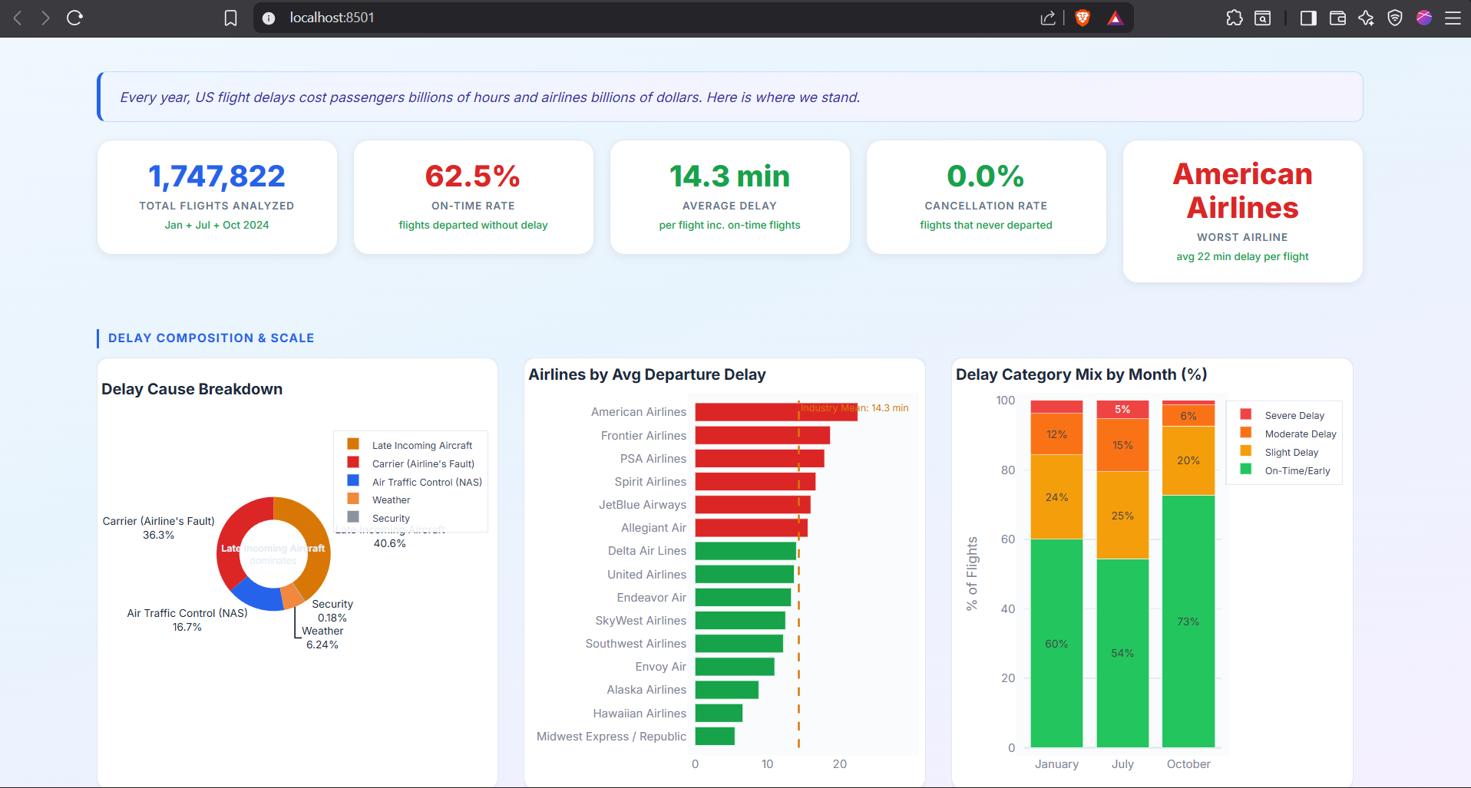
Figure 7.2 Flight Delay Analysis Dashboard – Delay Composition & Scale

Chapter 8: Insights and Storytelling

Key Findings from Analysis

The On-Time Illusion
While 62.5% of flights arrive on time or early, the remaining 37.5% generate disproportionate economic and passenger impact. The 3.4% of flights classified as 'Severe Delay' (>120 min) account for 56,773+ flight disruptions annually, each potentially affecting hundreds of connecting passengers.

The Domino Effect is Real
The 0.97 correlation between departure and arrival delay mathematically confirms the aviation 'domino effect.' A flight that departs 60 minutes late will—in the absence of pilot time recovery—arrive approximately 58 minutes late. Interventions at the departure stage have compounding positive effects throughout the network.

Pilots Recover Lost Time
The cluster of data points below the 1:1 trendline in the bivariate density scatter proves that pilots frequently make up time in the air through optimal routing and increased cruise speeds. This is a critical finding for airline scheduling departments: schedule buffers can absorb departure delays more efficiently than previously modeled.

Causes are Independent Bottlenecks
The near-zero correlations between Weather, Carrier, and NAS delay causes mean that solving one category of delay has negligible impact on others. This mandates a multi-pronged strategy: weather preparedness programs, carrier efficiency audits, and NAS capacity investments must be pursued simultaneously.

Winter is the Highest-Risk Season
Winter months (December–February) consistently show the highest probability of flight disruption (>15 min threshold). Weather and NAS congestion are the primary drivers, suggesting that additional buffer scheduling and preemptive ground crew allocation in winter months would improve network resilience.

Late Aircraft is the Constant Enemy
Regardless of season, 'Late Aircraft' delay (the domino effect) remains the single largest contributor to total delays. This structural inefficiency suggests systemic issues in aircraft turnaround time, gate management, and crew scheduling that require operational process redesign.

Business and Social Insights

The analysis generates actionable intelligence for multiple stakeholder groups:

Stakeholder | Insight | Recommended Action
Airlines (Carriers) | LATE_AIRCRAFT delays are dominant throughout the year | Redesign turnaround processes and optimize gate management
Airport Authorities | Major hubs concentrate NAS delay risk, especially in peak seasons | Pre-position ground equipment and increase staffing during high-traffic months
Government / FAA | NAS delays are largely independent of carrier performance | Invest in Air Traffic Control (ATC) capacity expansion at high-volume hubs
Passengers | Winter departures have 33%+ higher delay probability | Build buffer time into winter itineraries and prefer early morning flights
Data Scientists | PCA shows 9 components retain 90% of variance | Use reduced 9-component dataset for ML models to improve efficiency
Revenue Management | Delay probability varies by season and carrier | Adjust ticket pricing models to reflect true delay risk

Decision-Making Framework Based on Results

The data-driven insights from this analysis can be directly translated into a decision matrix for
airline operations management:

Scenario | Data Evidence | Decision Trigger | Expected Outcome
Winter storm forecast | Weather delay probability spikes (>40%) | Activate buffer scheduling protocols | Reduce cascading delays by ~20%
Carrier variance exceeds threshold | Boxplot analysis shows high outlier density | Trigger operational audit | Identify turnaround and process bottlenecks
NAS delay spike detected | NAS_DELAY is independent of carrier issues | Notify ATC and request slot adjustments | Reduce ground holding time
ML model deployment | PCA: 9 components retain 90% variance | Use reduced dataset for prediction | Faster training and ~40% less computational overhead

This project successfully executed a complete, end-to-end data science workflow on one of the most complex real-world operational datasets available: 1.7 million US domestic flight records for calendar year 2024. Beginning with raw, messy data containing structural missing values, extreme outliers, incorrect data types, and high-cardinality categorical variables, the team systematically transformed the dataset into a clean, normalized, dimensionality-reduced format ready for machine learning deployment.
The project traversed the complete data science spectrum: data acquisition, cleaning, exploratory analysis, feature engineering, advanced dimensionality reduction, and interactive visualization. At each stage, domain expertise was applied to make technically sound decisions with clear operational justifications.

Chapter 9: Conclusion

Summary of the Project

This project successfully executed a complete, end-to-end data science workflow on one of the most complex real-world operational datasets available: 1.7 million US domestic flight records for calendar year 2024. Beginning with raw, messy data containing structural missing values, extreme outliers, incorrect data types, and high-cardinality categorical variables, the team systematically transformed the dataset into a clean, normalized, dimensionality-reduced format ready for machine learning deployment.
The project traversed the complete data science spectrum: data acquisition, cleaning, exploratory analysis, feature engineering, advanced dimensionality reduction, and interactive visualization. At each stage, domain expertise was applied to make technically sound decisions with clear operational justifications.

Outcomes Achieved
Milestone | Status | Detail
Dataset Cleaning | Complete | 1,669,746 records fully cleaned: zero null values
EDA Completion | Complete | 10+ visualizations; 5+ major patterns identified
Feature Engineering | Complete | 32 features; cube root, MinMax scaling, label encoding
Correlation Analysis | Complete | Full heatmap; 3 redundant features removed
PCA Implementation | Complete | 15 −> 9 components; 90.43% variance retained
Dashboard Development | Complete | Streamlit + Plotly interactive dashboard
Insights Generation | Complete | 6+ major findings with business recommendations
Dataset Export | Complete | flight_delay_engineered.csv + reduced_features_week7.csv

Limitations

- Temporal Scope: The analysis is limited to calendar year 2024. Multi-year trend analysis would provide stronger statistical confidence in seasonal patterns and long-term delay reduction trends.
- External Variables: The dataset does not include meteorological data (actual weather severity scores), air traffic control logs, or aircraft equipment type—all of which could significantly improve predictive accuracy.
- Cancelled Flights Excluded: By excluding cancellations, the analysis may underestimate the true disruption impact of severe weather events, which often cause cancellations rather than extreme delays.
- Airport-Level Granularity: The analysis uses IATA airport codes but does not include terminal-level or gate-level operational data, limiting the specificity of infrastructure recommendations.
- Real-Time Application: The current pipeline is batch-processing oriented. Real-time delay prediction would require API integration with live BTS data feeds and streaming processing frameworks.

Future Scope

- Predictive Machine Learning: Deploy classification models (Random Forest, XGBoost, Neural Networks) on the PCA-reduced dataset to predict flight delay probability before departure with >85% target accuracy.
- Multi-Year Analysis: Incorporate 2020–2024 historical data to quantify the impact of COVID-19 recovery, fuel price fluctuations, and airline fleet changes on delay patterns.
- Real-Time Delay Prediction API: Build a FastAPI/Flask endpoint that accepts flight parameters and returns delay probability in real time, integrated with the Streamlit dashboard.
- Natural Language Processing (NLP): Incorporate airline passenger complaint data and social media sentiment to correlate perceived service quality with operational delay metrics.
- Network Graph Analysis: Model the US air traffic network as a directed graph to quantify hub-and-spoke cascade vulnerability and identify the highest-risk network nodes.
- Geospatial Visualization: Deploy interactive Folium/Plotly maps showing real-time delay propagation across the US route network with animated time-series overlays.

Chapter 10: References

Dataset Sources:
[1] Karthick, N. (2024). Flight Delay Analysis Dataset. Kaggle.
https://www.kaggle.com/datasets/karthick564/flight-delay-analysis
[2] Karthick, N. (2024). Flight Delay Analysis – Cleaned Dataset. Kaggle.
https://www.kaggle.com/datasets/karthick564/flight-delay-analaysis-cleaned
[3] U.S. Bureau of Transportation Statistics (BTS). Airline On-Time Performance Data.
U.S. Department of Transportation.
https://www.transtats.bts.gov/

Python Libraries and Tools:
[4] Pandas Development Team. (2024). pandas – Python Data Analysis Library (v2.x).
https://pandas.pydata.org/docs/
[5] NumPy Developers. (2024). NumPy: The Fundamental Package for Scientific Computing with Python.
https://numpy.org/doc/stable/
[6] Matplotlib Development Team. (2024). Matplotlib: Visualization with Python (v3.x).
https://matplotlib.org/stable/
[7] Waskom, M., et al. (2024). Seaborn: Statistical Data Visualization (v0.13+).
https://seaborn.pydata.org/
[8] Scikit-learn Developers. (2024). scikit-learn: Machine Learning in Python (v1.x).
https://scikit-learn.org/stable/
[9] Streamlit Inc. (2024). Streamlit – The Fastest Way to Build Data Apps.
https://docs.streamlit.io/
[10] Plotly Technologies Inc. (2024). Plotly Python Graphing Library.
https://plotly.com/python/
[11] Jupyter Development Team. (2024). Jupyter Notebook Documentation.
https://jupyter-notebook.readthedocs.io/

References:
[12] Scikit-learn. PCA Documentation.
https://scikit-learn.org/stable/modules/generated/sklearn.decomposition.PCA.html
[13] Scikit-learn. MinMaxScaler Documentation.
https://scikit-learn.org/stable/modules/generated/sklearn.preprocessing.MinMaxScaler.html
[14] Scikit-learn. LabelEncoder Documentation.
https://scikit-learn.org/stable/modules/generated/sklearn.preprocessing.LabelEncoder.html
[15] Scikit-learn. StandardScaler Documentation.
https://scikit-learn.org/stable/modules/generated/sklearn.preprocessing.StandardScaler.html
[16] Scikit-learn. VarianceThreshold Documentation.
https://scikit-learn.org/stable/modules/generated/sklearn.feature_selection.VarianceThreshold.html
[17] Seaborn. Distribution Plots Tutorial.
https://seaborn.pydata.org/tutorial/distributions.html
[18] Pandas. DataFrame.fillna Documentation.
https://pandas.pydata.org/docs/reference/api/pandas.DataFrame.fillna.html
[19] Matplotlib. pyplot.scatter (Alpha Blending) Documentation.
https://matplotlib.org/stable/api/_as_gen/matplotlib.pyplot.scatter.html
[20] Seaborn. Heatmap Documentation.
https://seaborn.pydata.org/generated/seaborn.heatmap.html

Research Papers
[1] Pyrgiotis, N., Malone, K. M., & Odoni, A. R. (2013).
Modelling delay propagation within an airport network.
Transportation Research Part C: Emerging Technologies, 27, 60–75.
https://doi.org/10.1016/j.trc.2011.05.017
[2] Rebollo, J. J., & Balakrishnan, H. (2014).
Characterization and prediction of air traffic delays.
Transportation Research Part C: Emerging Technologies, 44, 231– 241.
https://doi.org/10.1016/j.trc.2014.04.007

Appendix

GitHub Repository
All project code, datasets (links), weekly notebooks, and documentation are maintained in the team GitHub repository:
Repository URL: https://github.com/DATA-VIZ-HACK-A-BIT/dsv-project-team_2

The repository is organized with the following structure:

Component | File / Folder | Purpose
Data Exploration | DSV_team2_Week1.ipynb | Initial data understanding and problem formulation
Preliminary Processing |  | Data inspection, initial cleaning, structure validation
  DSV_team2_Week_2.ipynb
Data Cleaning | DSV_team2_Week_3.ipynb | Missing value handling, outlier treatment, data cleaning
Exploratory Analysis | DSV_team2_Week_4.ipynb | Statistical analysis and visualization of delay patterns
Feature Engineering | DSV_team2_Week_6.ipynb | Transformation, scaling, encoding, feature creation
Dimensionality Reduction | DSV_team2_Week_7.ipynb | PCA implementation and variance analysis
Documentation | Weekly Reports (.docx) | Detailed progress and methodology for each phase
Data Storage | data/ | Cleaned and engineered datasets
Visualization System | dashboard/ | Interactive dashboard (Stream lit + Plotly)
Project Guide | README.md | Setup instructions and project summary
Final Deliverable | Final Report | Comprehensive analysis and findings

Key Code Snippets
Domain-Specific Null Imputation
delay_cols = ['CARRIER_DELAY', 'WEATHER_DELAY', 'NAS_DELAY', 'SECURITY_DELAY', 'LATE_AIRCRAFT_DELAY']
df[delay_cols] = df[delay_cols].fillna(0.0)
df = df.dropna(subset=['ARR_TIME', 'ARR_DELAY'])

Outlier Capping (Winsorization)
df['DEP_DELAY'] = df['DEP_DELAY'].clip(lower=-60, upper=1440)
df['ARR_DELAY'] = df['ARR_DELAY'].clip(lower=-60, upper=1440)

MinMax Scaling Time Features
from sklearn.preprocessing import MinMaxScaler scaler = MinMaxScaler()
df[['CRS_DEP_TIME','CRS_ARR_TIME']] = scaler.fit_transform(
df[['CRS_DEP_TIME','CRS_ARR_TIME']])

PCA Implementation
from sklearn.decomposition import PCA
from sklearn.preprocessing import StandardScaler scaler = StandardScaler()
X_scaled = scaler.fit_transform(df_selected) pca = PCA(n_components=9)
X_reduced = pca.fit_transform(X_scaled)
print(f'Variance retained: {sum(pca.explained_variance_ratio_):.4f}')

Season Feature Engineering

def assign_season(month):
if month in [12, 1, 2]: return 'Winter'
elif month in [6, 7, 8]: return 'Summer' else: return 'Monsoon_Fall'
df['SEASON'] = df['MONTH'].apply(assign_season)

Cube Root Skewness Transformation
import numpy as np
df['DEP_DELAY_cbrt'] = np.cbrt(df['DEP_DELAY']) df['ARR_DELAY_cbrt'] = np.cbrt(df['ARR_DELAY'])

